Source code manual for
USB Configurable Servo Firmware
1. About

After configuring “Servo_Firmware.ioc” file and generating code with STM32CubeMX, some code is inserted in sections ”USER CODE BEGIN/USER CODE END” in some files. And all non STM32CubeMX generated source files are placed in “Servo_Firmware/Core/Src/App/” directory.

Software used:
STM32CubeIDE - version 1.11.0
STM32 MCU Package for STM32F1 Series – version 1.8.4

Source code overall project organization:
- File “Servo_Firmware.ioc”
- Inserted code in sections ”USER CODE BEGIN/USER CODE END”
- Non STM32CubeMX generated folder “Servo_Firmware/Core/Src/App/” and everything in it

2. Notes for “Servo_Firmware.ioc” file

NVIC Controller configuration:
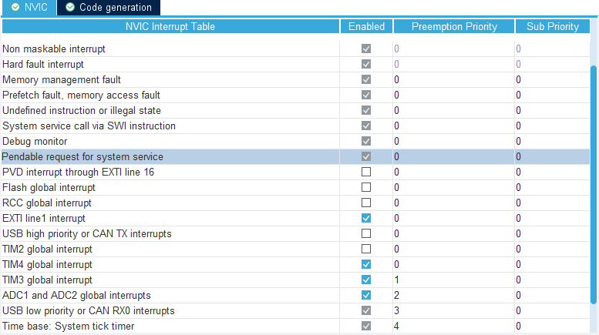
Interrupts “EXTI line 1” and “TIM4 global” are responsible to PWM input signal (position signal input to board) length measurement and timeout. They have equal highest interrupt priority, interrupting them with anything what takes significant amount of MCU cycles will lead to incorrect input signal length calculation, thus incorrect position or vibration.

Interrupt “TIM3 global” calls PID calculation on every overflow. PID calculation interruption with EXTI1/TIM4 interrupts could not cause any problem. Because TIM3 is runing in continuous mode and it’s countdown is going even while it’s interrupt handler is executing or when this handler is interrupted by another interrupt. Assuming that signal interrupts take very small amount of MCU cycles, handlers of these interrupts as well as PID calculation interrupt handler will exit timely before next “TIM3 global” interrupt occurs.

Next lower priority is USB, not sure how it’s interruption with all above interrupts can affect normal operation, but even anything such occurs, we will notice it by lost or incorrect data at MCU or PC side. I have not yet observed anything such.

Next and lowest priority has “Time base: System tick timer”. We use this interrupt for functions delay of which for some time will not affect system operation:
- Calling device input signal timeout function (indicates ”signal lost”)
- LED timeout function in position change mode
- motor timeout function when it is being testing from PC app (forward/backward rotation via PC app buttons)

ADC1 configuration:
ADC1 is used for detecting potentiometer position, by measuring voltage on it. As you can notice here, ”Vrefint” channel is not used for voltage calculation accuracy and we don’t actually calculate ADC input voltage at all. If there was any need in measuring of actual voltage to calculate position, it would have terrible drift without Vrefint taking in account. But because of input voltage to potentiometer is equal to microcontroller VDD voltage (not taking in account voltage drop on wires and any electrical noise on them), ADC results will always represent potentiometer position besides of actual VDD value.

3. Inserted code in sections ”USER CODE BEGIN/USER CODE END”

List of files and sections:
- File “Servo_Firmware\USB_DEVICE\App\usbd_cdc_if.c”
  - Section “/* USER CODE BEGIN INCLUDE */”
  - Section “/* USER CODE BEGIN 6 */”
    - Added only line “USB_Packet_Received(&Buf[0], Len[0]);”
  - Section “/* USER CODE BEGIN INCLUDE */”
- File “Servo_Firmware\Core\Inc\main.h”
  - Section “/* USER CODE BEGIN Includes */”
- File “Servo_Firmware\Core\Src\main.c”
  - Section “/* USER CODE BEGIN Includes */”
  - Section “/* USER CODE BEGIN 2 */”
  - Section “/* USER CODE BEGIN WHILE */”
4. Code in “Servo_Firmware/Core/Src/App/”

Organization map:

